Interview Notes
Interview Notes
Contacts

Contact Lists
Contact Name | Organization | Contact | Description
Leon Boey | Living Seas | +65 9641 6580
Emil Arifin | Businessman / resort / BioRock | +62 811-183-468
Gregory | OK OCE Translator | +62 811-3807-107
Graham Abbot | Diver | ‪+62 813‑3867‑3026‬
Frank | Sea Trek | +62 857-9284-1325 | Hospitality but works closely with Coral Guardian; indirectly involved in restoration
Eko Arisyanto | Government (Minister of Finance Senior Analyst) | +62 811-101-762 | Interested in blue circular economy and environmental consulting long term
Edi Pindito | Pindito dive liveaboard | +62 812-3815-771 | https://www.youtube.com/user/MrEdifro  - developing a marine bio educational app  - pessimistic about restoration, more passionate about education
Angga A. Adinegoro | President Director Pulau Macan (Eco Lodge) | +62 815-8553-3397 | Hospitality but lodge is centered in National Park area north of Jakarta; indirectly involved with restoration efforts
Vera Damayanti | External Affairs for Sandiaga Uno | +62 813-1004-2068 | Sandiaga Uno = Founder of OK OCE and former Minister of Tourism
Ricard Buxo | Owner of Operator Oceanic Liveaboard | +62 812-3707-276 | -Head of Indonesia Liveaboard Association—Says it is not helpful  -Recognizes that the scaling of his business has now become a problem for coral reefs
Ardi | Bali Driver | +62 812-4689-3288 | Driver when we obviously will go to Bali again
Indonesia Biru Foundation | Elsa Dianita Aulia | elsa@indonesiabiru.id | Programming Director, Marine Biologist
Coral Catch | Avicenna Wijayanto | +62 859 7490 7574  cenna@coralcatch.org | Program Manager

https://scholar.google.com/citations?user=qHKTzjEAAAAJ&hl=en

2.Project goals

- Primary Goal for this term:
  - To compile and present a compelling, story-driven pitch that showcases:
    - What we learned from our interviews with coral restoration stakeholders in Indonesia
    - Why cross-collaboration between these stakeholders (e.g., divers, NGOs, resorts, villages) is crucial
    - How foreign tourists and partners can amplify and support these grassroots efforts
  - Deliverables:
    - A digital pitch deck aimed at stakeholders (NGOs, resorts, local leaders, and potential funders)
    - A curated set of collaboration matches with rationale (e.g., IBF x Pulau Macan), showing the benefit of working together
- Primary Goal for Next Semester
  - To scale awareness and practical uptake of the findings by:
    - Presenting your pitch to NGOs, universities, and eco-tourism orgs
    - Facilitating at least 2 real connections between stakeholders (e.g., helping IBF and Angga connect over email or Zoom)
    - Developing a tourist-facing storytelling campaign prototype
    - Sharing a public-facing report or story series that can appeal to funders, tourists, and policymakers

Potential Collaborations to Set Up

1. Living Seas × Coral Catch
- Why connect:
  - Living Seas has the technical depth and experience in restoration at scale (250K coral, drone mapping, structure-based planting).
  - Coral Catch has educational infrastructure, a strong training program for young Indonesian women, and is based in Gili — not far from Bali.
- Benefits:
  - Living Seas can help Coral Catch reduce equipment costs and improve restoration techniques.
  - Coral Catch can provide certified female divers and ongoing data monitoring post-program.
- Capacity:
  - Both are small teams but already partner with NGOs and seek impact scaling.
- Why collaboration > solo:
  - Together, they could create a model site with training + scalable restoration to showcase for donors and government alike.

2. Edi Pindito (Diver/Educator) × Coral Catch (Women-led Ed Program)
- Why connect:
  - Edi’s creating a marine education app and believes in youth education but needs help with outreach and content.
  - Coral Catch is empowering young women through education and diving.
- Benefits:
  - Coral Catch could beta test Edi’s app and help him translate content for younger audiences.
  - Edi could mentor their students and offer a new tool for post-program engagement.
- Capacity:
  - Coral Catch has direct access to students, and Edi is seeking partners.
- Why collaboration > solo:
  - Edi gains user testing + relevance; Coral Catch gains a free learning tool for youth.

3. Indonesia Biru Foundation (IBF) × Eco Lodge (Pulau Macan/Angga)
- Why connect:
  - IBF has deep ties in local villages, reef star experience, and works in Lombok.
  - Angga’s Eco Lodge is part of a national park in Thousand Islands and seeks certifications and education programs.
- Benefits:
  - IBF can share how to engage communities and get schools involved.
  - Angga can offer a real-world test site for trialing a more education-friendly eco-tourism model.
- Capacity:
  - IBF has worked across many schools, and Angga wants to increase visitor involvement and impact.
- Why collaboration > solo:
  - Together, they can create an eco-tourism + education package others can replicate, boosting both visibility and funding.

Changes Made to Original Proposal

Category | Original Proposal | Current Focus
Location | Jakarta-focused | Indonesia-wide
Approach | Top-down: model + policy + funding architecture | Bottom-up: highlight & connect what’s already working
Goal | Scale heat-resistant coral farming | Scale impact of existing grassroots coral efforts
Main Deliverables | Economic models, funding frameworks, religious analysis | Stakeholder matchmaking, pitch deck, storytelling platform
Primary Audience | Policymakers, financiers, religious leaders | NGOs, eco-tourists, grassroots orgs, resort owners
Funding Focus | Long-term sustainable finance models | Short-term visibility & support via foreign tourists + collabs
Your Role | Coral strategy consultants | Coral ecosystem connectors and communicators

3. Game Plan

- Can get done by April 9
  - Connect Edi with Dasu
    - Ask about viability of further out connections
    - Solidify plan for educational component - outline how to connect him with both foreign and domestic educational institutions
  - Research distinction between NGO and LLC capabilities from a tax and services perspective
    - Understand the inhibiting Sea Trek and various Coral Groups from forming a more explicit partnership
  - Decide between possible models - centralized community/circle for coral restoration updates, connecting specific stakeholders in pairs
  - Connect with Vincent Chalias (Ocean Gardener)
    - To frame him as a potential ambassador or validator of the collaborative coral restoration movement
  - Start developing pitch deck to propose collaboration between interviewees

- Next Semester
  - Finalize and polish the two core pitch decks for actual use:
    - One for connecting stakeholders and nGOs
    - One for tourism-facing storytelling collaboration ask
  - Facilitate at least two real collaborations between interviewees (ex. Co-hosted training, shared resource, joint coral nursery site etc)
  - Consider app / centralized platform

Tool Ideas
App ideas:

Figure out how to make ideas self-sustaining

Possible stakeholder categories / users: schools, universities, NGOs, hospitality businesses, divers, marine biologists, tourists, heads of fishing villages, aspiring entrepreneurs

- Collaboration platform to connect coral reef stakeholders who have similar needs, interests, geographical proximity, etc
  - ??We possibly act as the connecting entity??
  - AI can identify possible synergies between involved parties and help connect the dots
    - Users would need to input information about their current status, needs, supplies, desired partnerships, locations → app would help connect them with others who can help fill in their gaps
      - E.g. connect school with diving company that has boat and supplies
  - Would also help make use of supplies that aren’t in use during tourism down-seasons
    - E.g. eco-tourism entities offer their boats and guides to local schools for a discounted price during non-peak-season

- Coral restoration map - collects user input about active restoration locations and sites that need immediate attention
  - Can use satellite imaging to streamline the identification of areas at risk of coral bleaching and potential hotspots
    - (https://coral.org/en/coral-bleaching/remote-sensing-tools/) coral monitoring tools
  - Also provides information about methodologies, where to source supplies, etc
  - Can be used by NGOs, small villages and enterprises interested in restoration projects, individualis, eco-tourism, etc
  - Another app functionality: trip advisor / yelp but specifically for eco-projects
    - This specific feature would have a lot of competition
  - Extension of allen coral atlas? Separate app?
  - Integration with Edi’s app?

Research:
- Availability of coral satellite imaging
- Similar apps for other causes
  - Popularity, performance, investors, etc
  - Competitive landscape
- Viability of integration with existing tools like Allen Atlas
- Outreach and user acquisition strategy
- Revenue generation model
  - How can it be self sustaining
  - Who would manage the platform long term
  - Who would be a trustworthy neutral third party entity?
- How might different stakeholders interact
  - Opportunities for revenue and/or cost saving

Other tasks:
- Email outreach templates for Edi outreach
  - One for research
  - One for potential customers
- Update Edi on our outreach
- Identify outreach goals

Similar apps - Market Landscape

App | Purpose | Value to us
NCX | Tech company that provides precision date to optimize forest management, carbon sequestration, and wood-based products  - Analyzes your land to identify threats and opportunities  - Suggests revenue generating programs for your land, estimates potential earnings for nature opportunities  - Tree planting carbon  - Recreational leasing  - First carbon credits  - Solar farming | - Understand how to quantify ecological value economically
Rainforest Connection (RFCx) | Nonprofit conservation tech, use acoustic tech to protect rainforests from illegal logging and monitor biodiversity to better inform conservation
Reefhabilitation | Open access website for coral reef restoration practitioners to collect, visualize, and share their restoration monitoring data  - Enable better tracking of restoration efforts - support resource managers, scientists, tourism operators, and nonprofit orgs - understand and make decisions about their projects  - Tourism operators: start using the portal right away if they already have a nursery - educational videos, data collection and entry, data analysis  - Only has 2 sites - dominican republic - focused on caribbean  - Knowledge hub and restoration webinar series  - Coral restoration consortium - community of practice with scientists, managers, practitioners, educators - foster collaboration and tech transfer among participants  - Caribbean reef explorer mapping tool  - 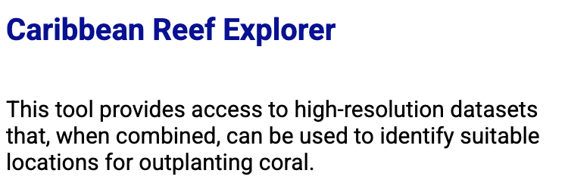 | - Similar to what we want to build  - Understand mapping technology, usage rates, outreach strategies, funding, etc  - E.g. funding structure - lead institutions are the nature conservancy (developed the program), reef resilience network, and coral restoration consortium / supporting organizations are booking.com, AGRRA, NOAA, Coral restoration foundation, corales de paz, grupo puntacana fundacion, etc
ReefSupport | Informal coalition and platform for organizations, small businesses, researchers, and members of the public that are interested in any aspect of coral reef conservation or restoration  - Mission is to foster cross-activity collaboration (creation, deployment, monitoring) - social outreach + educational awareness + impact  - Examples of orgs they work with: REEFolution Kenya, RRReefs Switzerland, Cape RADD South Africa  - Search by location  - 2 Indonesia locations  - Each destination has unique requirements, typically need some diving experience  - ReefRanger program - receive training to prepare them to undertake research-based activities at sea - identification training, coral baseline surveying, answer the question is conservation working, also deploy restoration  - All profits fund AI tools to fund more technology  - Use tech and sustainable travel to support marine conversation, connect passionate individuals | Similar to what we want to build  - Would be a good platform to share with Indonesia orgs we talked to - more from Indonesia should be on the map  - Understand satellite and monitoring technology / viability of augmenting a map  - Connecting global stakeholders - diving/ conservation entities and interested tourists - what stakeholders are left out?  - Small nonprofits like IBF?  - Foreign investors ?  - Carbon credit market?
CRC - Coral Restoration Consortium | - Storytelling hub - citizen documentarian series  - Neutral town hall dedicated to supporting communities and practitioners in implementing impactful coral restoration projects  - Primary audience is restoration practitioners in reef rich, low-income nations working toward coral diversity. Also help scientists and funders reach people and corals who need them.  - Remove traditional gaps in collaborative conservation by ensuring the info sharing is smooth  - Ensure that coral restoration is not dominated by a handful or large scale, high tech projects  - Resources e.g. spawning calendars, scientific papers, monitoring guides, video library - webinars, meetings, plenaries  - Regional groups - no group for Coral Triangle / Indonesia  - Working groups - dedicated to developing action plans for specific topics - eg larval propagation  - Board of directors come from other coral restoration orgs | - Leon on front page!!!  - Could help orgs develop a regional group in the Coral Triangle  - Fostering collaboration, both regionally and globally  - Consolidated collection of resources on all aspects of restoration, scientific and economic
Sea Foundry | - Safeguard and restore coral via scalable, efficient restoration technology  - Better faster cheaper - robotics, AI, computer vision - goal is to outpace the global decline of coral reefs  - Hardware automation to reduce manual labor and improve survival rates - enhance scalability and precision  - Software intelligence for predictive insights  - Partners: scientists and researchers, restoration practitioners and coral producers, government agencies, restoration funders, public, corporate sponsors  - Silicon valley team | - Bring global stakeholders together  - Scale at reasonable pace to actually make an impact (relative to decline)  - Collective of highly skilled people
Cordap | - Bring together scientific minds - transdisciplinary approach - accelerate and scale up tech to support international conservation efforts  - Change the current trajectory - restoration is most expensive and dominated by short term projects - only suitable for small scale intervention  - Open source platform  - Activities are governed by Initiative Governing Committee, representing several nations and intentional orgs  - Platform central node administers the overall platform, fully supported by Saudi Arabia University - King Abdullah University of Science and Technology  - Support scientific projects selected through global, targeted calls for proposals  Cordap foundation - G20 initiative | Collaboration platform, privately funded for open access  Accelerate and scale restoration
Scaling up: the app that’s transforming lives in South African fishing communities -  Abalobi | - Cultivate thriving climate resistant small scale fishing communities  - Connect fisher groups  - Poise small scale fishers for social, economic, and ecological sustainability  - Enable technologies, invest in communities, data empowerment, inclusion and recognition, fisheries improvement  - Co-design enabling technologies in partnership with small scale fishing communities - use software to efficiently manage community-supported fishery - support data collection initiates, help meat catch reporting and traceability requirements | Tailored toward local villages, often an overlooked stakeholders  - Promote sustainability without overlooking their economic needs, build solution that works for everyone  - 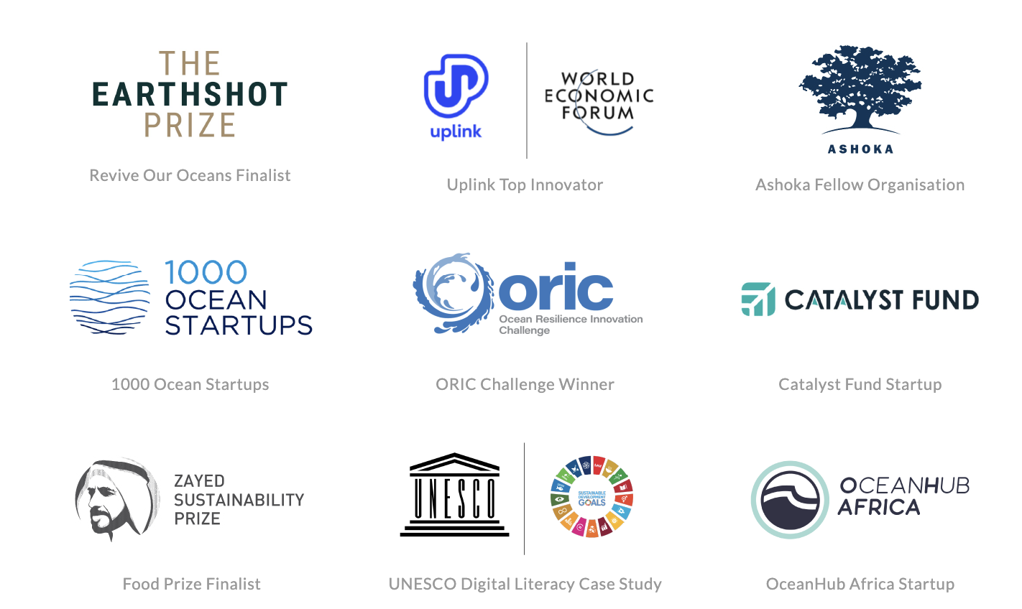
iNaturalist | Every observation can contribute to biodiversity science - share findings with data repositories to help scientists find and use your data  - Keep track of encounters with wildlife  - Crowdsource identifications  - Learn about nature  - Record observations → share with fellow naturalists → discuss findings | Involves everyday people who are interested in nature but lack ecological or economic expertise
Withlocals | Connect tourists with meaningful experiences, “committed to sustainability” | - Opportunity to add designated sustainability section to their website - eg in search filter, add an option for eco-tourism  - Get more coral restoration orgs on their platform to expose more tourists to their opportunities
Viavii | Connect tourists with meaningful personalized travel experiences | Add sustainability option
ReefAdapt | Reef Adapt was designed to allow rapid incorporation of genetic, biophysical and environmental data in marine restoration and conservation initiatives.

New ideas to fill in gaps:

- A Coral Restoration Coordination Hub for Southeast Asia (esp. Coral Triangle/Indonesia) Gap:

- No regional group under the Coral Restoration Consortium (CRC) for the Coral Triangle
- Existing platforms (Reefhabilitation, ReefSupport, etc.) focus mostly on the Caribbean or individual orgs in Indonesia without integration
- Many small, local Indonesian orgs are underrepresented globally
- Opportunity:
  - Build a lightweight digital hub that:
  - Aggregates existing coral restoration efforts in Southeast Asia
  - Helps orgs form a regional coalition (with resources, contacts, templates)
  - Showcases project maps, open data, and resource-sharing tools
  - Helps local groups apply for global funding (translate grant info, eligibility)

- Eco-Impact Explorer: Map-Based Tool for Tourists + Restoration
  - Gap:
    - Tourists don’t know how to get involved with local conservation/restoration
    - Platforms like WithLocals or Viavii don’t let users filter for reef restoration/eco-activities
    - Local orgs aren’t easily discoverable (esp. small, non-English-speaking ones)
  - Opportunity:
    - Create a mobile-friendly web app that:
      - Uses mapping (open source or satellite) to show conservation/restoration tourism spots
      - Lists training opportunities, diving requirements, costs, time commitments
      - Allows coral orgs to self-register (like a “Google My Business” for restoration)
      - Links to platforms like ReefSupport and CRC for deeper engagement

- Micro-Conservation Marketplace for Locals
  - Gap: Most platforms cater to scientists or tourists; few tools for local community stakeholders like fisherfolk or coastal villages (except Abalobi, but it's fisheries-focused)
  - Small orgs don’t know how to monetize restoration or access carbon markets
  - Opportunity: build a basic platform that:
    - Helps local communities monetize micro-restoration efforts (e.g., coral planting, water quality monitoring)
    - Offers "impact tokens" or connects them with funders/investors
    - Uses SMS or simple Android apps for low-tech regions
    - Incorporates storytelling tools (inspired by CRC’s citizen documentarian hub) to amplify their voices
4. "Coral Equity Hub" – Stakeholder Mapping + Inclusion (somewhat similar with idea #2)
- There's no app/platform that:
  - Maps all restoration stakeholders in Indonesia, from grassroots orgs (e.g., IBF) to foreign investors, government agencies, and tour operators.
  - Identifies who is left out of funding, training, tourism partnerships, etc.
  - Offers micro-grant tools, needs registry, or skills matchmaking.
- Why it’s unique: Moves beyond tech and tourists to build a full-circle economic and restoration ecosystem—bottom-up support, not just top-down funding.
- Could use gamification or tokenization to drive community participation.

5. Localized Coral Restoration Toolkit for Small Orgs

- Platform to support emerging community-based reef orgs in Indonesia with:
- Templates for project planning, cost estimates, monitoring protocols.
- “Restoration Starter Kit” with funding leads, equipment sourcing guides, sample permit docs.
- Peer network for mentorship from more established players.

- Why it’s a need: A lot of Indonesian orgs you’ve spoken to don’t have access to the same resources as bigger players. This app levels the playing field.

FOR MAP DEVELOPMENT (TALK TO ANDY)
- Should be a website

★ Indonesia coral restoration map - highlight ecologically viable locations + consolidate stakeholders, make information on optimal restoration more accessible
- We are removing the barrier to scientific research and physical restoration

Layer Importance:
- Must have
- Should have
- Nice to have
- Not necessary

Map Layers:

Ecological & Environmental Layers
Layer | Purpose | Data Sources
Reef Location & Health | Show current coral reef cover, bleaching history, and health index | Allen Coral Atlas, ReefBase, local NGOs
Sea Surface Temperature (SST) | Identify heat stress zones, future bleaching risk | NOAA Coral Reef Watch
Ocean Acidification / pH | Predict areas of future vulnerability | IUCN, CMEMS (Copernicus Marine Service)
Chlorophyll Concentration / Nutrients | Indicate water quality and potential eutrophication | NASA MODIS Aqua, Copernicus
Sedimentation / Turbidity | Highlight areas with runoff risk, which affect coral growth | Local watershed models, satellite turbidity data
Mangrove & Seagrass Proximity | Co-benefits of adjacent ecosystems for resilience | Global Mangrove Watch, UNEP

🧑‍🤝‍🧑 Social & Economic Layers
Layer | Purpose | Data Sources
Local Community Density / Villages | Prioritize community-inclusive restoration | OpenStreetMap, BPS (Indonesia’s national statistics agency)
Small-Scale Fishing Activity Zones | Identify areas that depend on reefs for livelihood | Indonesia's Ministry of Marine Affairs and Fisheries (MMAF), Abalobi-style community inputs
Marine Tourism Hotspots | Overlay restoration with eco-tourism potential | Dive site databases, TripAdvisor scrape, Withlocals/Viavii
Coastal Protection Value | Estimate economic value of reef in reducing wave energy, storm surge | The Natural Capital Project, InVEST models
Marine Protected Areas (MPAs) | Evaluate protection status and legal feasibility | Indonesian MPA map, WCMC Marine Protection Atlas

🏗️ Infrastructure & Logistics Layers
Layer | Purpose | Data Sources
Boat Access / Port Locations | Assess ease of deployment for nurseries, coral transport | OpenStreetMap, local port authorities  https://www.openstreetmap.org/  Blue dashed lines = common boat routes
Restoration Projects (Active / Past) | Show where work has been done already, who is active | Coral Restoration Consortium, ReefSupport, user submissions  Self research on restoration efforts
Restoration Infrastructure | Identify nurseries, labs, training centers | NGO networks, universities, local orgs  Self research on restoration efforts

🧠 Science & Suitability Layers
Layer | Purpose | Data Sources
Thermal Resilience / Heat-Tolerant Corals | Overlay findings from survivability research like your work with Palumbi | Your field data + ReefAdapt + local studies
Larval Connectivity Models | Understand how coral larvae spread and connect reefs | CORDAP projects, published research
Substrate Suitability | Areas with hard bottom types vs sandy/muddy | Seafloor mapping surveys, bathymetry data (GEBCO, NOAA)

🔧 Bonus Interactive Layers
- “Opportunity Zones” (composite score based on ecological need + community readiness)
- “Urgency Heatmap” (overlay of climate risk + reef degradation)
- “Funding Gaps” (based on number of active projects vs need)
- User-generated layers (allow orgs to upload restoration plans, nursery sites, needs)

🧩 Possible Features

Feature | Useful for
Map of orgs and projects | All stakeholders
Restoration profile pages | Small orgs, tourists, scientists
Tool matching AI wizard | Restoration practitioners, owners of diving equipment
Tourism activity search/filter | Tourists, ecotourism experience providers
SMS and whatsapp integration | Local villages, community groups
Data upload / citizen logging | Scientists
Grant support section | Small orgs

Stakeholders:
- Figure out what each individual one can contribute to restoration
  - E.g.:
    - Diving center has equipment
    - Fishing villages have boats
    - Rich businessmen have money
    - Eco lodges have tourists
    - Marine biologists have recommendations for improving survival rates
- Target users:
  - Anyone interested in restoration?
    - Tourists, individuals, local villages, small orgs, schools, tourist entities, investors, marine scientists and researchers, economists, etc
  - Financial focus
    - Investors, nonprofits, those who apply for or issue grants,
  - Narrow nonprofit x tourism focus
    - Nonprofits with coral restoration aspirations, tourist entities with physical supplies and/or land ownership for restoration
    - Marketing intermediaries and booking agencies
    - Tourists and/or tourist agencies

Individual Report Topics
3 main topics
- Environmental viability - Anica Camacho
- Potential implementable business models - Riley Pierce
- Employment impacts - Marina Parker

